PROJECT REPORT

**“GENERATION OF ELECTRIC ENERGY FROM NOISE POLLUTION”**

**Submitted to**

**Tolani foundation gandhidham polytechnic**

**under**

**Gujarat technological university**

**in**

**Partial Fulfilment of Requirements for the diploma in Department of electrical Engineering**

Submitted By:-

Ajit Kulkarni 196510309005

Faculty Guide HEAD OF DEPARTMENT

NIMESH PRAJAPATI J.K.RATHOD

CIRTIFICATE

DATE:-

This is to certify that the project entitled “GENERATION OF ELECTRIC ENERGY FROM NOISE POLLUTION” has been carried out by ARJUN CHANGLA, AJIT KULKARNI, HARSHVARDHAN GADHVI, AYUSH SHRIVASTVA Under our guidance in fulfilment of the Diploma in ELECTRICAL ENGINEERING (5th Semester) of Gujarat Technological University, Ahmedabad during the academic year 2021.

Faculty Guide HEAD OF DEPARTMENT

NIMESH PRAJAPATI J.K.RATHOD

**ACKNOWLEDGEMENT**

***We are greatly thankful to Nimesh Prajapati sir, Professors Neeraj sir and Utpal sir, J.K. Rathod the head of the Dept. of Electrical Engineering and other faculty members for giving us an opportunity to learn and do this project. If not for the above mentioned people, our project would never have been completed in such a successfully manner.***

**REREFERNCE SITES:**

1. [**https://www.wikipedia.org**](https://www.wikipedia.org)
2. [**https://www.youtube.com**](https://www.youtube.com)
3. [**https://www.quora.com**](https://www.quora.com)
4. [**https://www.definition.org**](https://www.definition.org)

Contents

CHAPTER 1: INTRODUCTION 5

CHAPTER 2: COMMON ALTERNATING SOURCE 6

Chapter 3: Where can we harvest sound? 9

CHAPTER 4: COMPONENTS 14

CHAPTER 5: WORKING PRINCIPAL 20

CHAPTER 6: CIRCUIT DIAGRAM 22

CHAPTER 7: DECIBEL CHART OF DIFFERENT AREAS 23

CHAPTER 8: USES 24

PROJECT PICTURE

# CHAPTER 1: INTRODUCTION

**Sound has a potential to produce the electrical energy.**

**But how?  
  
*In our surrounding there is too much of noise (sound vibration or sound signals). So, with the help of absorbing speaker (which absorbs the sound energy) and step up signal transformer. We can produce the electrical energy.***

***How much energy could we produce?***

**For each 100db we get 0.5 volts**

**1000db 5volts**

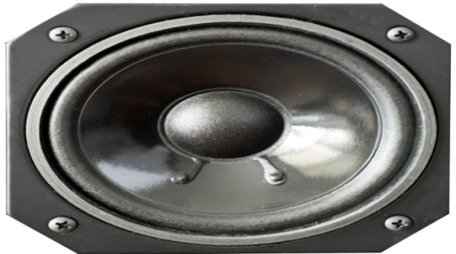

# CHAPTER 2: COMMON ALTERNATING SOURCE

1. **HYDRO POWER PLANT**

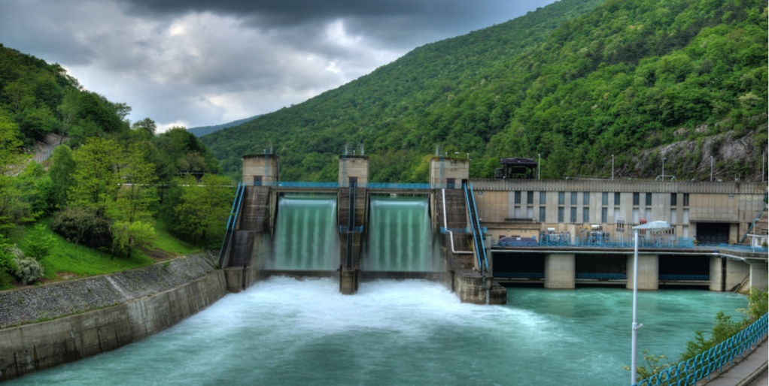

**2) WIND POWER PLANT**

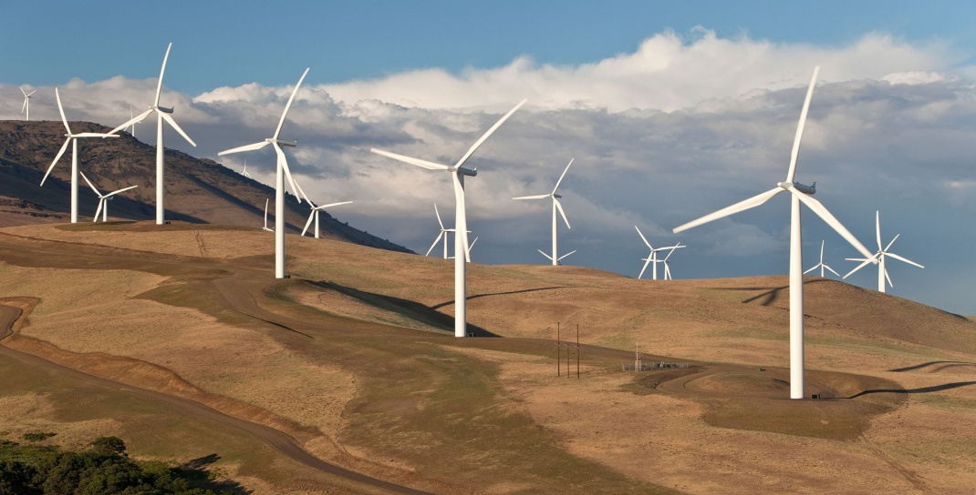

1. **SOLAR POWER PLANT**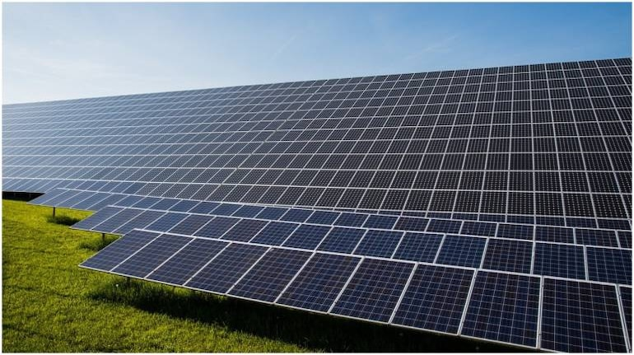
2. **THERMAL POWER PLANT**

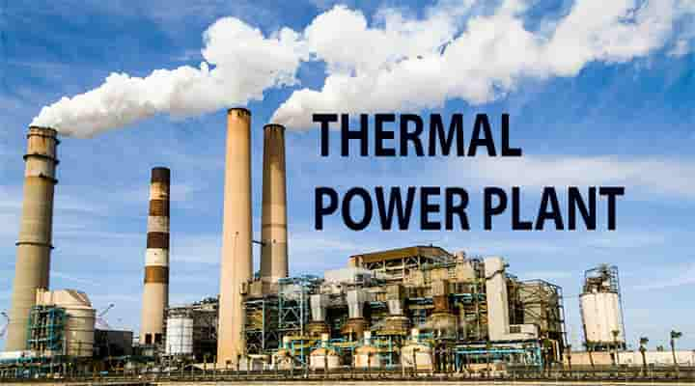

1. **GEOTHERMAL POWER PLANT**

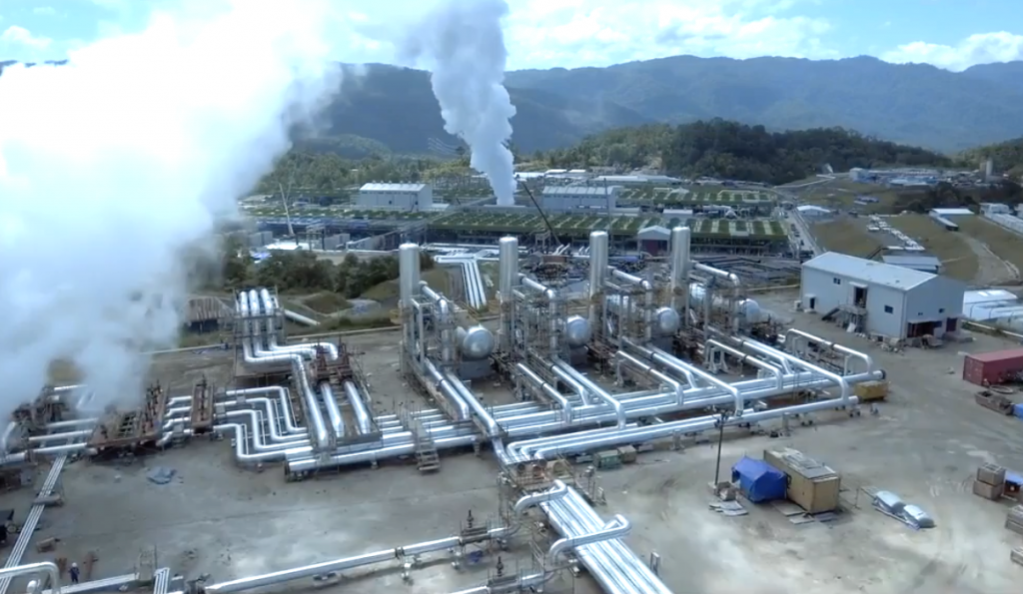

1. **BIOMASS POWER PLANT**

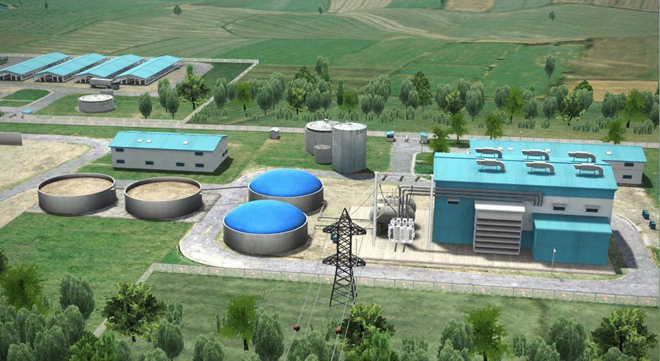

# Chapter 3: Where can we harvest sound?

**1)Traffic Area:-**

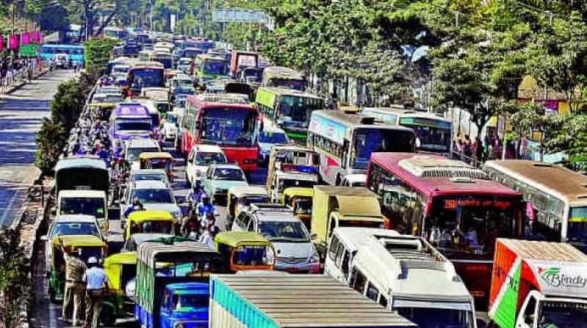

**IN 2019 IN BANGALORE INDIA’S BIGGEST TRAFFIC JAM HAS FOUND. SEVERAL SUCH BIG TRAFFIC’S HAS ALSO FOUND IN MUMBAI, PUNE, OR DELHI**

**Traffic congestion** is a condition in transport that is characterised by slower speeds, longer trip times, and increased vehicular queueing. Traffic congestion on urban road networks has increased substantially, since the 1950s.[[1]](https://en.wikipedia.org/wiki/Traffic_congestion#cite_note-1) When traffic demand is great enough that the interaction between vehicles slows the speed of the traffic stream, this results in some congestion. While congestion is a possibility for any mode of transportation, this article will focus on automobile congestion on public roads.

**2)Cricket Stadium:-**

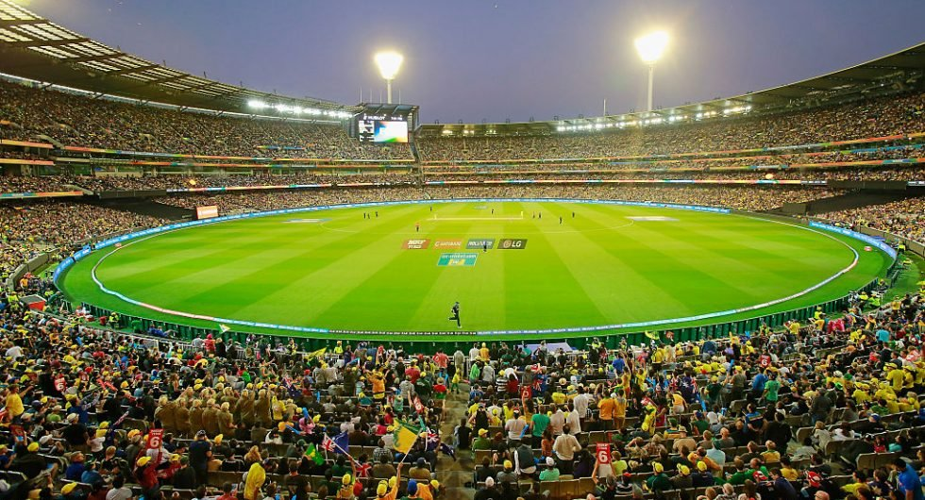

**IN CRICKET STADIUM SUCH AS NARENDAR MODI STADIAM AND MELBOURME CRICKET STADIUM HAS CAPACITY OF MORE THAN 1 LAKH PEOPLE WHICH PRODUCE SO MUCH SOUND.**

The **Narendra Modi Stadium**, commonly known as the **Motera Stadium**, is a cricket stadium situated inside the Sardar Vallabhbhai Patel Sports Enclave  in Ahmedabad, Gujarat, India. As of 2021, it is the largest stadium in the world, with a seating capacity of 132,000 spectators. It is owned by the Gujarat Cricket Association and is a venue for Test, ODI, and T20I cricket matches.

The stadium was constructed in 1983 and was first renovated in 2006. It became the regular venue for international matches in the city. In 2015, the stadium was closed and demolished before being completely rebuilt by February 2020, with an estimated cost of ₹800 crore (US$110 million).

**3)Railway Station:-**

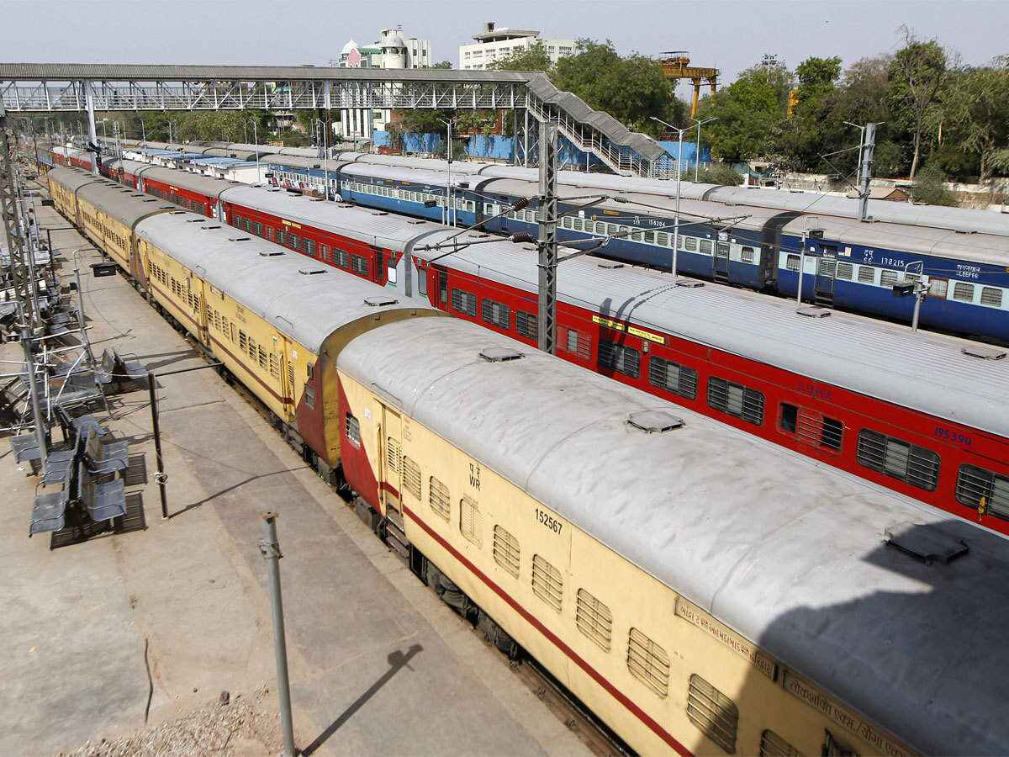

A **train station**, **railway station**, **railroad station** or **depot** is a railway facility or area where trains regularly stop to load or unload passengers, freight or both. It generally consists of at least one track-side platform and a station building (depot) providing such ancillary services as ticket sales, waiting rooms and baggage/freight service. If a station is on a single-track line, it often has a passing loop to facilitate traffic movements.

Places at which passengers only occasionally board or leave a train, sometimes consisting of a short platform and a waiting shed but sometimes indicated by no more than a sign, are variously referred to as "stops", "flag stops", "halts", or "provisional stopping places".

Stations may be at ground level, underground or elevated. Connections may be available to intersecting rail lines or other transport modes such as buses, trams or other rapid transit systems.

**4)Industrial Area:-**

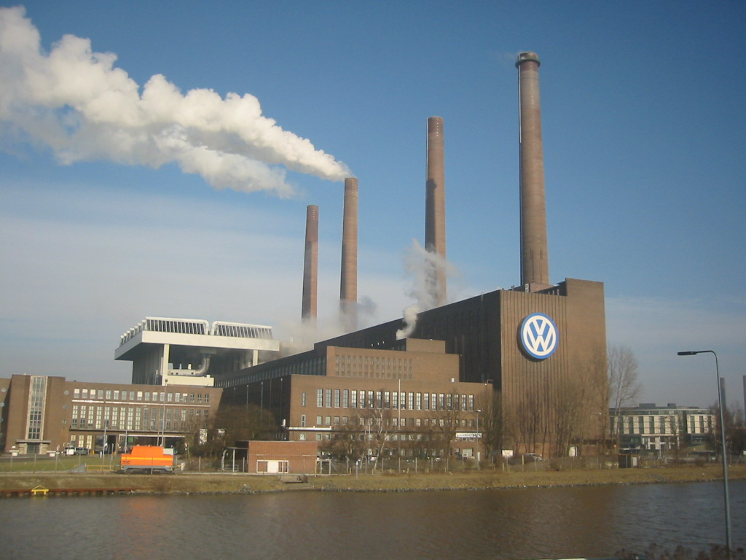

* Industry (economics), a generally categorized branch of economic activity
* Industry (manufacturing), a specific branch of economic activity, typically in factories with machinery
* The wider industrial sector of an economy, including manufacturing and production of other intermediate or final goods
* The general characteristics and production methods common to an industrial society
  + Industrialization, the transformation into an industrial society
* Industry classification, a classification of economic organizations and activities

**5)Live Concert:-**

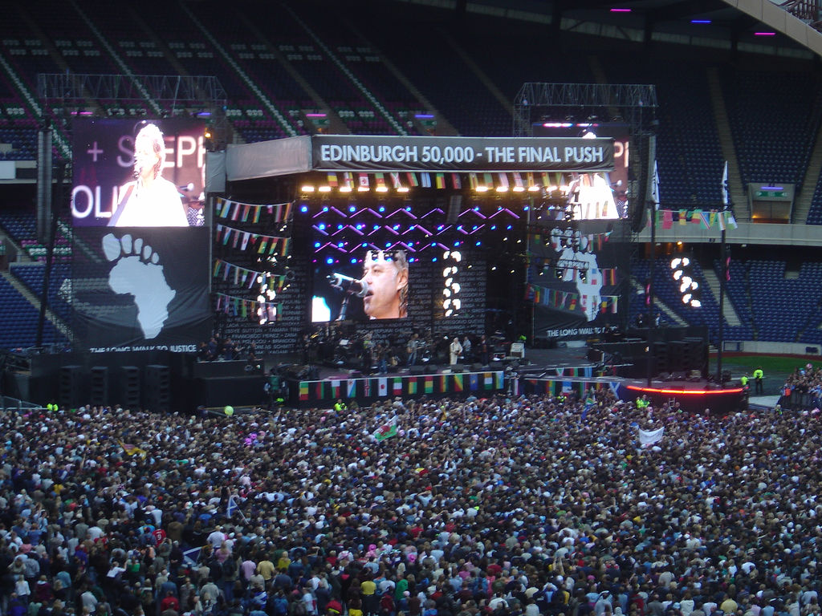

A **concert** is a live music performance in front of an audience. The performance may be by a single musician, sometimes then called a **recital**, or by a musical ensemble, such as an orchestra, choir, or band. Concerts are held in a wide variety and size of settings, from private houses and small nightclubs, dedicated concert halls, amphitheatres and parks, to large multipurpose buildings, such as arenas and stadiums. Indoor concerts held in the largest venues are sometimes called *arena concerts* or *amphitheatre concerts*. Informal names for a concert include *show* and *gig*.

Regardless of the venue, musicians usually perform on a stage (if not actual then an area of the floor designated as such). Concerts often require live event support with professional audio equipment. Before recorded music, concerts provided the main opportunity to hear musicians play. For large concerts or concert tours, the challenging logistics of arranging the musicians, venue, equipment and audience (ticket sales) are handled by professional tour promoters.

# CHAPTER 4: COMPONENTS

**1)Absorbing Speakers:-**

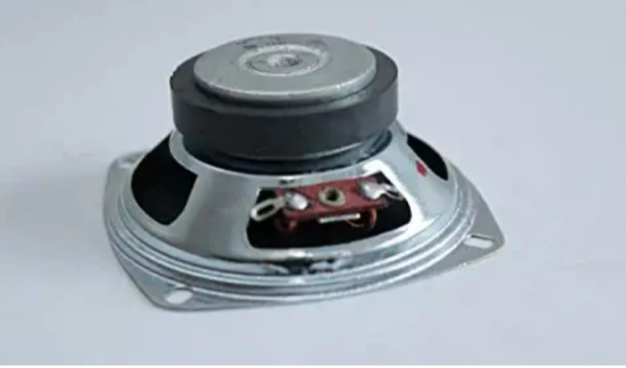

1) THIS IS THE MAIN COMPONENT OF THE PROJECT.SPEAKER IS USE TO ABSORB THE SURROUNDING SOUND.

2) SPEAKER SIZE: - 3 INCH

3) - SPEAKER PRICE: - 90 RS 1 UNIT

4) REQUIRED SPEAKER: - 5 UNIT

**2)Step-UP Signal Transformer:-**

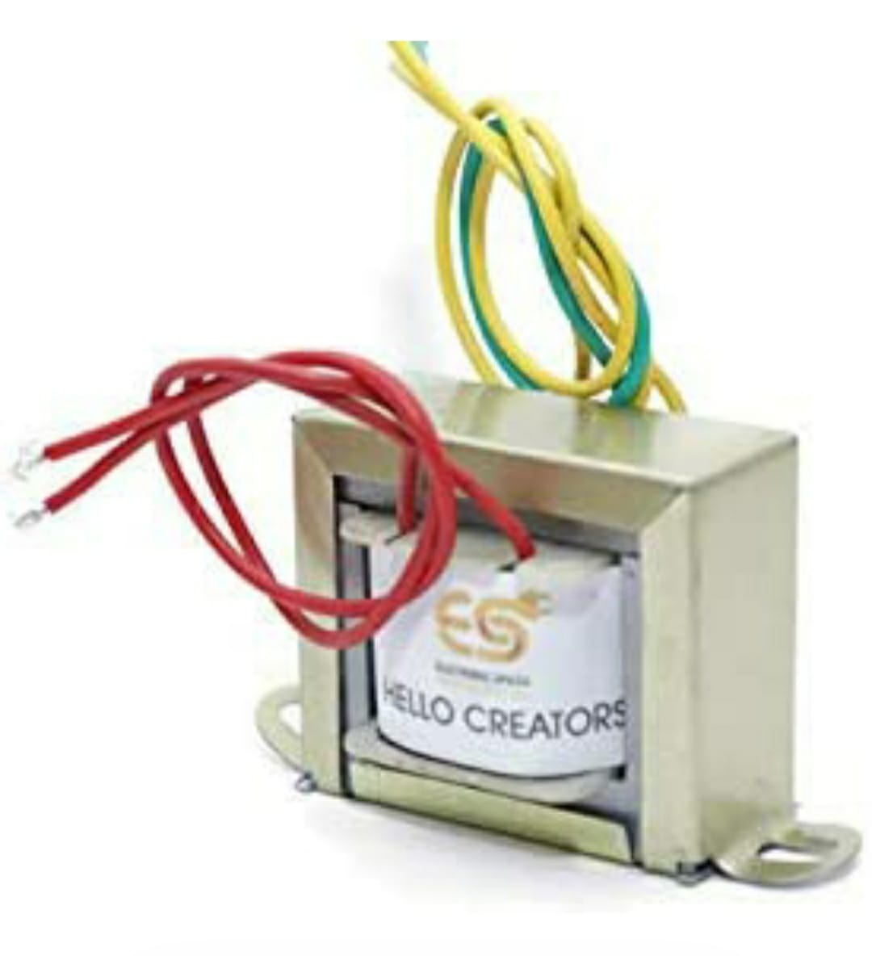

THE MAIN WORK OF TRANSFORMER IS TO INCERASE THE LEVEL OF SIGNAL COMING FROM THE SPEAKERS.

(LOW SIGNAL ---- HIGH SIGNAL)

1. TRANSFORMERS RANGE– 12V TO 22OV
2. TRANSFORMERS PRICE – 100 – 1 UNIT
3. REQUIRED TRANSFORMER – 2 UNIT

**3)LED:-**

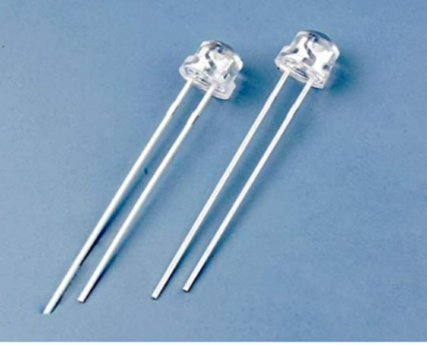

**(LIGHT EMITTING DIODE) = LED IS USED IN STREET LIGHT AND BUILDING, ETC.**

**4)Capacitor:-**

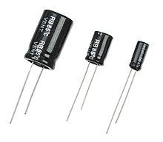

**The capacitor is a component which has the ability or “capacity” to store energy in the form of an electrical charge producing a potential difference (Static Voltage) across its plates, much like a small rechargeable battery.**

**5)Indicator:-**

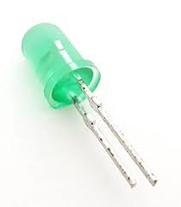

**A small electric light used to indicate something**... often used to show an operating condition or whether power is on, these lights come in a range of colors and voltages.

**6)Switches:-**

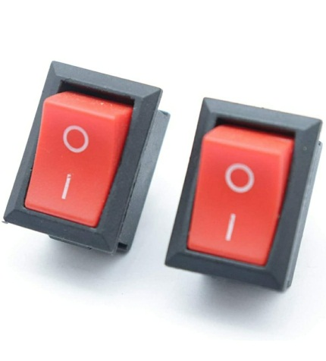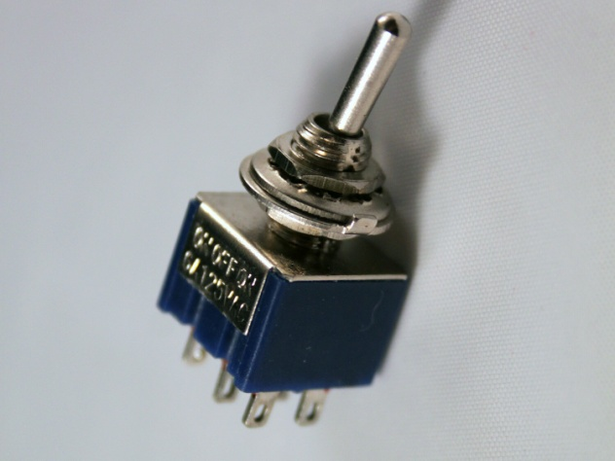

**SWITCHES: - IT IS USED TO ON/OFF. It is also used to complete the circuit.**

**1)One way switches**

**2) Two way switch:- *In a two-way switch, there are two, one-way switches combined in one. One of the terminals can be connected to either of the two, but not both at the same time. The advantage of a two-way switch is the ability to control a single device from two separate locations.***

**7)PCB, CONNECTING WIRES & BATTERY**

***\*PCB*: -** PRINTED CIRCUIT BOARD.PCB IS USE BOTH FOR BORE AND ASSEMBLED BOARDS .

**PRICE–** 69RS

***\*CONNECTING WIRES: -*** WIRES ARE USED TO CONNECT THE EQUIPMENT FROM EACH OTHER (LUMP SUM).

***\*BATTERY*:** - IT IS USED TO BE STORE THE POWER GENERATED FROM THE SPEAKER.

**PRICE: -** 500RS

**REQUIRED: -** 1

**8)POWER AMPLIFIER:-**

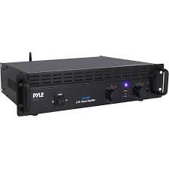

A power amplifier is **an electronic amplifier designed to increase the magnitude of power of a given input signal**. The power of the input signal is increased to a level high enough to drive loads of output devices like speakers, headphones, RF transmitters etc. ... In this case, a microphone is used as an input source.

# CHAPTER 5: WORKING PRINCIPAL

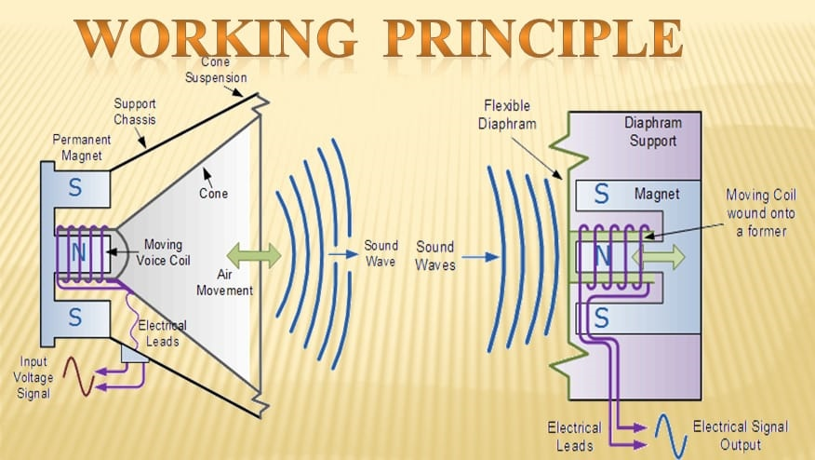

* **THE CONVERSION OF SOUND ENERGY INTO ELECTRICAL ENERGY.**
* **WHEN THE SOUND ENERGY (SIGNALS) IS ABSORBED BY ABSORBING SPEAKER.**
* **AND THEN THE SOFT LAYER OF DIAPHRAGM ON THE UPPER SIDE GETS VIBRATE.**
* **BY THIS VIBRATION THE MOVING COIL IN IT ALSO VIBRATE.**
* **AND WITH THE HELP OF FIELD MAGNET THE VIBRATION CUTS THE FIELD FLUX LINE.**
* **AND THE ELECTRICAL SIGNAL IS PRODUCED.**

**THESE ELECTRIC SIGNAL ARE STEP – UP AND CAN BE USED AS ELECTRICAL ENERGY**

# CHAPTER 6: CIRCUIT DIAGRAM

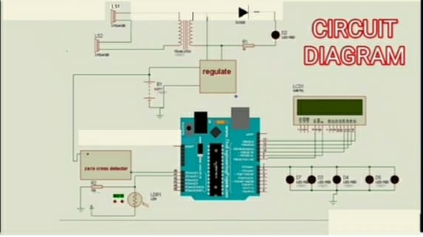

# CHAPTER 7: DECIBEL CHART OF DIFFERENT AREAS

# CHAPTER 8: USES

* ***NOTE:*** AS PER WE KNOW THAT THE POTENTIAL OF ENERGY PRODUCED BY SOUND IS A BIT LESS THAN OTHER SOURCES OF ENERGY. HENCE, WE HAVE TO MAKE THE USE OF THIS ENERGY AS PER NEARBY LOCATIOIN. SO WITH THAT WE CAN REDUCE THE LOSSES IN TRANSMISSION AND ITS EFFICIENCY WILL INCREASE.

**1)Electric Car Charging:-**

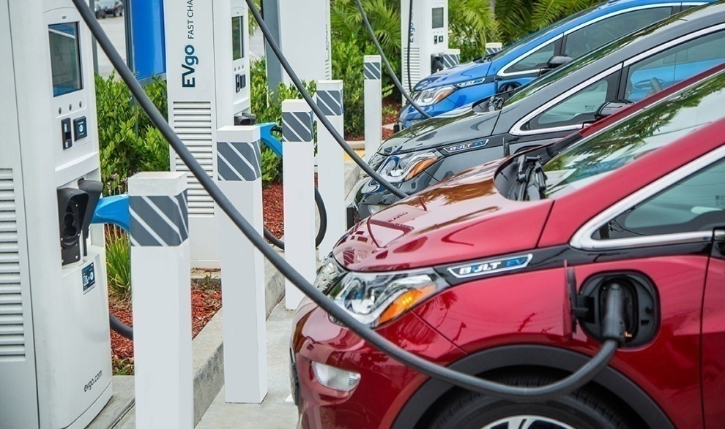

**AS CHARGING STATION ARE NEARER TO ROADS SO THE ENERGY PRODUCED BY SOUND IS TRANSMITED TO THE STATION AND MAKE THE USE OF THIS.FROM OUR RESEARCH WE HAVE FOUND THAT THE ROAD BETWEEN DELHI TO CHANDIGARH HAS BECOME THE FIRST ELECTRIC ROAD AND IN FUTURE IT WILL INCREASE THE ELECTRIC CRISIS IN INDIA . SO WITH THIS SOUCRE WE CAN OVERCOME THE SITUATION.**

**2)Street Lights:-**

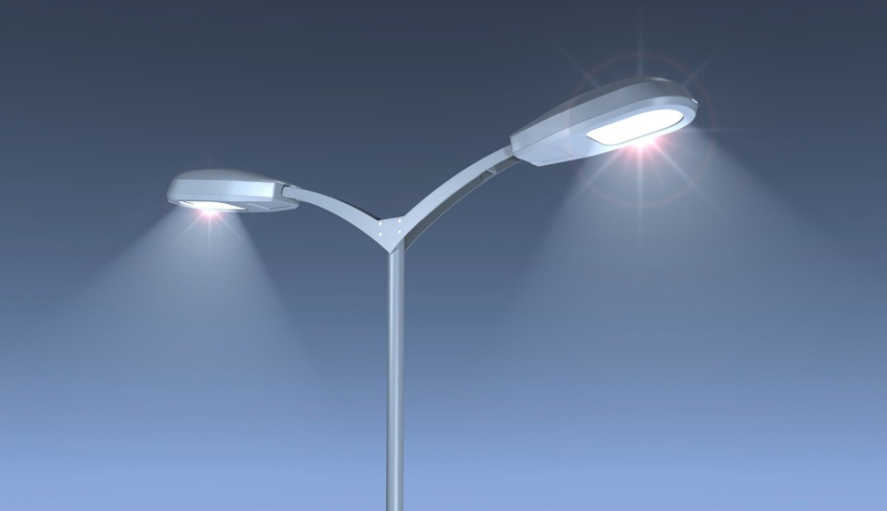

**Public street lighting was first developed in the 16th century, and accelerated following the invention of lanterns with glass windows, which greatly improved the quantity of light. In 1588 the Parisian Parliament decreed that a torch be installed and lit at each intersection, and in 1594 the police changed this to lanterns. Still, in the mid 17th century it was a common practice for travellers to hire a lantern-bearer if they had to move at night through the dark, winding streets. King Louis XIV authorized sweeping reforms in Paris in 1667, which included the installation and maintenance of lights on streets and at intersections, as well as stiff penalties for vandalizing or stealing the fixtures. Paris had more than 2,700 street lights by the end of the 17th century, and twice as many by 1730. Under this system, streets were lit with lanterns suspended 20 yards (18 m) apart on a cord over the middle of the street at a height of 20 feet (6.1 m); as an English visitor enthused in 1698, 'The streets are lit all winter and even during the full moon! In London, public street lighting was implemented around the end of the 17th century; a diarist wrote in 1712 that ‘All the way, quite through Hyde Park to the Queen’s Palace at Kensington, lanterns were placed for illuminating the roads on dark nights.**

**3)Cricket Stadium Lights :-**

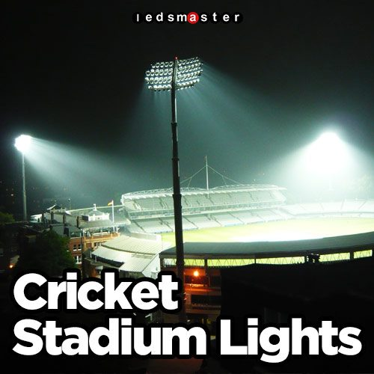

**A floodlight is a broad-beamed, high-intensity artificial light. They are often used to illuminate outdoor playing fields while an outdoor sports event is being held during low-light conditions. More focused kinds are often used as a stage lighting instrument in live performances such as concerts and plays.**

**In the top tiers of many professional sports, it is a requirement for stadiums to have floodlights to allow games to be scheduled outside daylight hours. Evening or night matches may suit spectators who have work or other commitments earlier in the day, and enable television broadcasts during lucrative primetime hours. Some sports grounds which do not have permanent floodlights installed may make use of portable temporary ones instead. Many larger floodlights (see bottom picture) will have gantries for bulb changing and maintenance. These will usually be able to accommodate one or two maintenance workers.**

# PROJECT PICTURE

